Period

* + Time required for a full oscillation is called period of oscillation sym: T
* Frequency
  + the inverse of a period
    - (hc)frequency = (1/period)
* Amplitude
* Waves
  + Concept of vibrations extends into the phenomenon of wave motion
  + Transverse waves
    - For transverse waves the wave’s amplitude is perpendicular to the wave’s motion
  + Longitudinal Waves
    - For longitudinal waves, amplitude and wave motions are parallel
* Medium
  + Any material that a wave moves in
* Wave length
  + Longitudinal (lambda)
    - Compression to compression
    - rarefaction
  + Traverse
    - Crest
    - Trough
* Wave Speed
  + The speed at which a wave travels is called a wave speed
  + Speed of sound = 330 m/s = 725 miles/hr
  + Speed of light 300,000,000 m/s (c=lowercase) 3x1-^8
* Tsunami Waves

Tsunamis are ordinary water waves just like waves in your bathtubs

Wave Relation

(Wave Speed) = (wavelength) x (Frequency)

Constructive interference

Two waves in phase add together, which is called constructive interference.

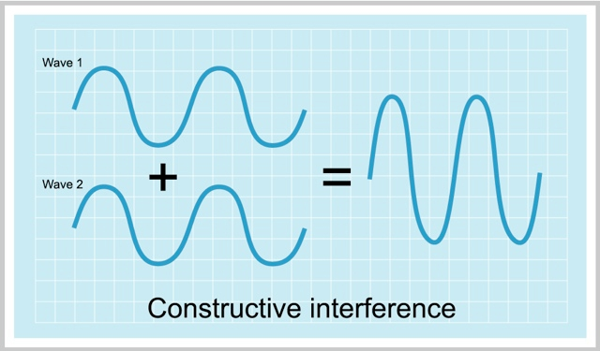

Destructive Interference

Two waves out of phase cancel each other out which is destructive interference.

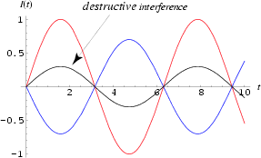

Beat Frequency - Happens from constructive and destructive interference.

Standing waves

When a wave interferes with its reflection, this may create a standing wave

Doppler Effect

Sound coming from a moving object that has a different wavelength and frequency than if it were stationary. If moving towards you, wavelength shorter and frequency higher.

Sound

Origin of Sound

Sound in air is a longitudinal wave created by compressions and rarefactions.

Sound waves can only travel through a material such as air, water

Light and radio waves can travel through vacuum

Sound travels better through elastic liquids and solids, such as water and rocks, than through air.

This is due to the close proximity of the atoms as they vibrate.

Your voice sounds different to you when you hear it from a recording,

Loudness and amplitude

Loudness depends on amplitude of pressure and density variations in sound waves.

Decibels

Loudness of sound depends on amplitude of pressure variations in the sound wave.

Loudness is measured in decibels (dB) which is logarithmic scale (since our perception of loudness varies logarithmically.

Hearing acuity decreases with age.

Hearing loss

The hair cells that line in the cochlea are a delicate and vulnerable part of the ear. repeated or sustained exposure of loud noises destroys the neurons of the organ of corti

Speed of sound in air

speed of sound in air 340m/s

sound travels one kilometer in 3 seconds about one mile in 5 seconds. light is a million times faster than sound

Sound reflects of rough surfaces, and soft surfaces absorb sound.

Refraction of Sound

Sound speed can vary by material or conditions

this causes the sound to bend in the direction in the same way that light bends when it passes through a glass lens

Ultrasound

Ultrasound is high frequency (mega hertz) short wavelength (0.1mm) sound

reflections and refreactions of ultrasound by flesh and bone allow seeing inside the human body